Sample Midterm 1

**(Note: Python was used before, C and Fortran will be used in Midterm)**

1. (2 points) In the following questions, identify if the Python 3 code represents an *expression*, an *assignment statement*, or an *error* by entering the corresponding letter.

A. Assignment Statement B. Expression C. Error

* 1. “Five”//len(“Five”)
  2. i=10//3
  3. “One”*len(“Three”)
  4. [i//2 for i in “Statement” if i]
  5. a = [i for i in “Statement”]

1. (3 points) Given the following function, indicate the result of calling this function with the indicated parameters in the space provided.

def func(a = 2, c = 3):

if not a%2:

return c//a

return a//c

1. func(10,4)
2. func()
3. func(2,6)
4. (4 points) Given the following recursive function, indicate the result of calling this function with the indicated parameters in the space provided.

def func(a = 5, b = 10):

return func(b//a,a) if not b%5 else sum(range(a*b))

* 1. func(1,5)
  2. func(3,5)
  3. func(1,10)
  4. func()

1. (4 points) Given the following simple grammar, indicate if the following sentences are valid with a T for true or F for false in the space provided.

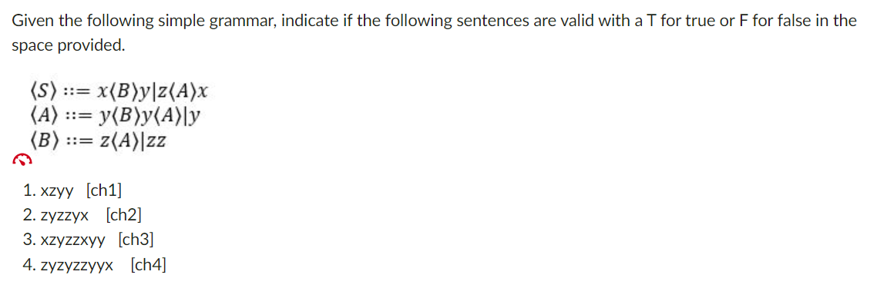

1. (4 points) For each of the following regular expressions, identify what it yields (if anything) when applied to the original input string (quotes NOT included): "First : Sun Mar 10 18:00:48 2021"

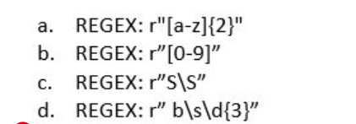

6. (2 points) In programming languages using dynamic typing, ________

a. Developers need to explicitly declare the type of variables before using them.

b. The program will infer all variable types at compile-time.

c. Variables must be initialized to a default value in the source code.

d. The variables’ types are usually inferred at run-time.

7. (2 points) SQL and HTML both are examples of ___________ programming languages.

a. Proprietary

b. Object-Oriented

c. Domain-specific

d. Static

8. (3 points) Enter the exact Python 3 slice syntax (without using anything else) that, when used on the string “Python3.0” will print “th”.

9. (2 points) What does the lexical analyzer do?

a. Discards comments and gathers characters into lexemes.

b. combine code from different modules into a single program

c. Checks for semantic errors and translates the program into an intermediate language similar to assembly.

d. none specified

10. (3 points) Define orthogonality.

11. (3 points) Evaluating programming languages by Readability, what is meant by overall simplicity?

13. (3 points) What are the phases of a interpreter?

14. (5 points) Write a Python 3 function that takes three values, and determines if these values could be the sides of a right triangle.